Physical Electronics
Department of Electrical and Computer Engineering
The University of Akron
Dr. George C. Giakos
Due on Monday November 11, 2013
Project 3

Design Of Nanotube Field-Effect Transistor (FET): Integration of Semiconductors with Nanotechnology

The key-idea of this project is to present the design and engineering principles of a Nanotube Field-Effect Transistors (FET)s as well as address any application area of your interest such as microelectronics, integrated electronics, optoelectronics, or as sensor (chemical, biological, gas, ect). The outcome of this study will allow one to realize how starting from basic semiconductor electronics concepts and principles is possible to design and fabricate novel semiconductor nanostructures which rely on the integration and blending of the FETs knowledge with nanotechnology.
- Background and Significance
Miniaturization and high performance pushes engineers towards the development of exotic transistors and advanced integrated circuits with unique electrical characteristics. The reason for using carbon nanotubes are the following: a) High current density and conductivity; b) fast response; c) nanotubes are chemically inert without surface effects; c) unique handling and separation properties.
The design principles of the IBM Single-Wall Carbon Nanotube Field-Effect Transistors (CNFETs) is shown in Fig. 1.
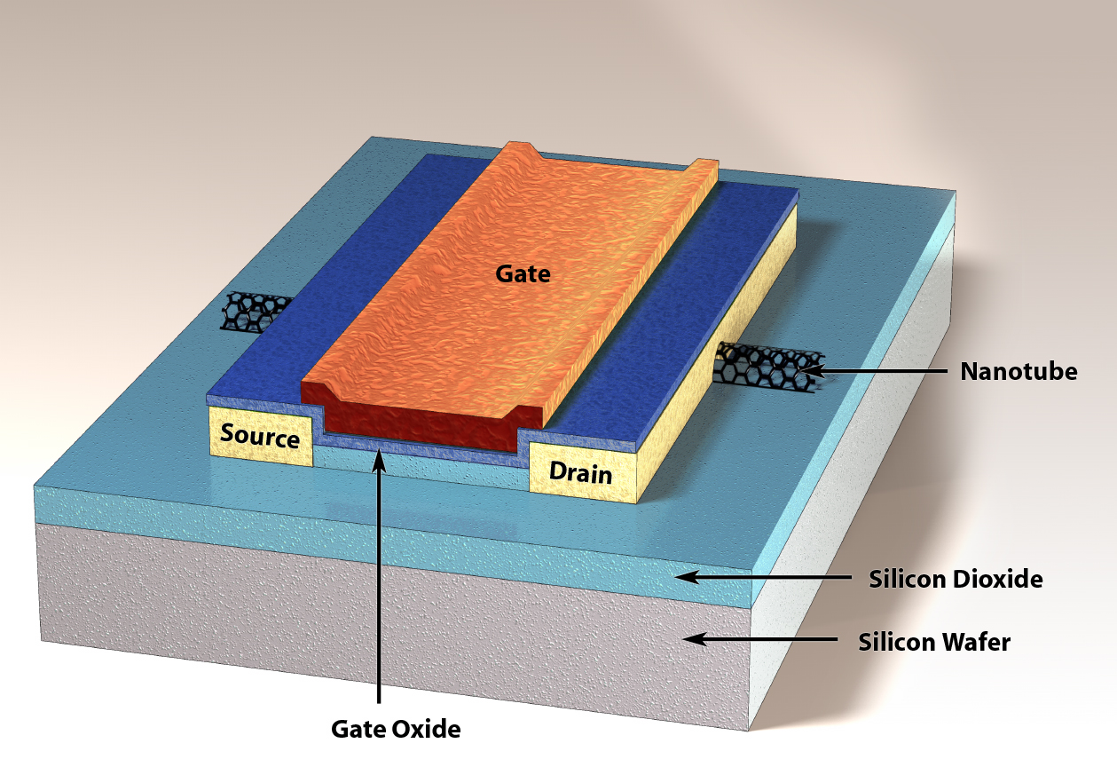
Fig. 1 The IBM Single-Wall Carbon Nanotube Field-Effect Transistors (CNFETs) [1]
By twisting a metallic nanotube, semiconductors with a band-gap that varies with the twist angle can be formed as shown in Fig. 2.
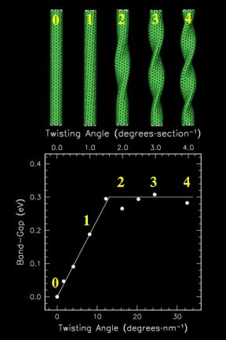

Fig. 2 Energy gap versus Twisting Angle [2]
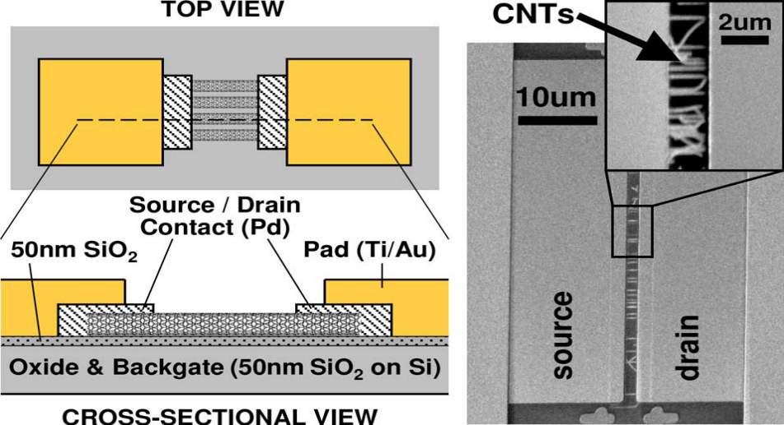
Fig. 3 Design of a Multiple-nanotube CNFET structure [3].

- Questions to addressed
- What are carbon nanotubes? Introduce carefully the physical and electrical characteristics of nanotubes.
- By looking at Figure 1, the IBM Single-Wall Carbon Nanotube Field-Effect Transistors can be visualized as an depletion-mode NMOS transistor where the implanted n-type channel region has been substituted with a nanotube channel. (However, enhancement type designs are possible).
How nanotubes can improve the I-V characteristics of a FET transistor? Which electrical parameters are mostly affected? (Hint: You may look at the mathematical model equations of the NMOS transistor and highlight electrical parameters of interest).

- What are the advantages, disadvantages, and limiting factors of the nanotube-based transistors over conventional FETs?

- How this exciting technology could impact integrated electronic devices, and optoelectronic devices?

- Can you discuss the design and engineering principles of a Nanotube Field-Effect Transistor applied in any area of your interest such as microelectronics, optoelectronics, or as high-sensitivity chemical sensor?

Please, formulate your answers carefully, following the IEEE Format.
- References

[1] Single-Wall Carbon Nanotube Field-Effect Transistors (CNFETs), http://domino.watson.ibm.com/comm/pr.nsf/pages/news.20020520_nanotubes.html
[2] R. Martel, T. Schmidt, H. R. Shea, T. Hertel, and Ph. Avouris, Single- and multi-wall carbon nanotube field-effect transistors, Applied Physics Letters, vol. 73, vol. 17, pp. 2447-2449, 1998.
[3] Albert Lin, Nishant Patil, Koungmin Ryu, Alexander Badmaev, Lewis Gomez De Arco, Chongwu Zhou, Subhasish Mitra, and H.-S. Philip Wong, “Threshold Voltage and On–Off Ratio Tuning for Multiple-Tube Carbon Nanotube FETs”, IEEE Transactions on NanoTechnology, ,Vol. 8, No. 1, pp. 4-9, January 2009

